TRAP GROUNDS, OXFORD
RECORD SHEET
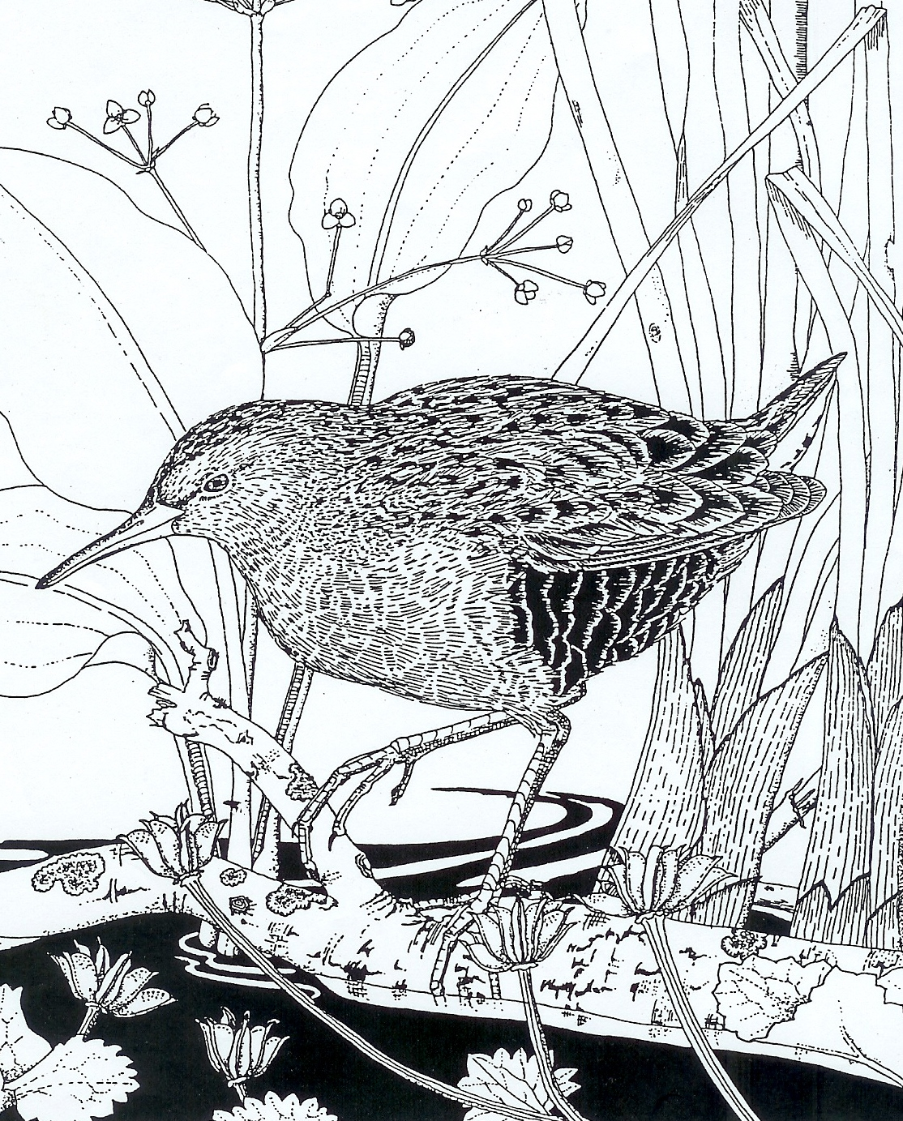
Name of recorder (Please give full name) |  |  |  |  |  | Email or other contact details
Date  Day/  Month/  Year | Name of species | Did you take a photo?  Y/N | Number  Please  |  |  | Location  Please  habitat type.  Add local Trap Grounds name for the area, if you know it.  You can find the names on the map at the Trap Grounds website  http://trap-grounds.org.uk |  |  |  |  | Notes  e.g. male/female  eggs/larvae/pupae  feeding on  tree trunk  flowering
Date  Day/  Month/  Year | Name of species | Did you take a photo?  Y/N | 1 - 5 | 5 - 10 | 10 + | Habitat Please  |  |  |  | Local Trap Grounds name
 |  |  |  |  |  | Reed bed / big pond | Other open water | Scrubland / Woodland | Grassland/ Open area | Local Trap Grounds name
Please email completed form to catherine.m.robinson@homecall.co.uk or post to Catherine Robinson, 12 Hayfield Road, Oxford, OX2 6TT

